s p a n i s h s i g n i f i c a n c e

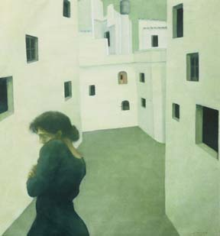

t h e p l a c e
I first travelled to Spain in 1996 to participate in a studio arrangement owned and operated by an artist from Britain. With a suitcase filled with canvas, and little else, I boarded a bus to follow a narrow, twisting road high into the mountains where Spain's pueblo blancos (white villages) glare surrealistically under the sun. Located in the southern region known as Andalucia, about 1.5 hours northeast of Malaga, my destination was a village of 4,000 people, a lively community set within a fertile area known primarily for its olive oil and wine. Goat paths wind from village to village, lined with various cacti and a profusion of flowers, while the surrounding hillsides are also rich in the production of almonds, carob, oranges, lemons and avocados. With the Mediterranean clearly visible (the village is only one half hour from the coast ) on certain days, when the conditions are right, Africa lies like a mirage in the distance.
For a Canadian escaping the doldrums of February, the village - its location, its white buildings and circuitous, narrow streets, its people who were warm, genuine and patient with foreigners - seemed almost heartbreakingly beautiful.
For three years, until it closed its doors in 1999, I stayed at Fuente Studios, an old house in the village centre which accommodated up to four artists at a time for periods of two to four months. Here, I had the privilege of meeting and working alongside artists from various countries, most notably England and Denmark but also Tasmania, the US and Japan. I have continued to return to the village where there is a small population of foreign artists residing permanently, and several others, who as I, return for a few months each year to work intensely.
i n s p i r a t i o n
What it is about Spain that inspires is not easy to define. Were I a landscape painter, the explanation would be easy enough as I would then be responding directly to a singular element of the country - a specific region, a particular place, a moment in which that place is observed - and, however abstract the approach, the result would be a form of documentation. Were I a figurative painter of another sort, intent on capturing, realistically or otherwise, the image of life as it exists, then, being in a particular place at a particular time has an obvious purpose, as well. The way I am inspired by Spain, however, is less concrete.
Rather than responding directly to my environment, I was able to gain a sense of the culture through interaction and internalization. Spain, as I've experienced it, is a bit of a paradox, a place wherein contradictions coexist comfortably, where passions run high in seemingly opposite directions without fear of contention. The Spaniards' devotion to religion and family do not conflict with their lust for life; rather, food, wine, dance and festivities are inextricably interwoven into celebrations of the church. Spain is a place where apparent opposites merge symbiotically, where despite the diverse elements which cohabit their culture, an almost effortless balance reigns.
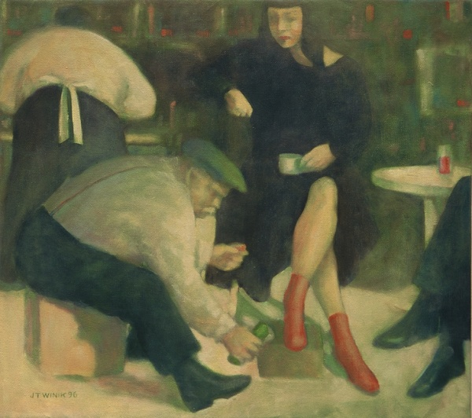
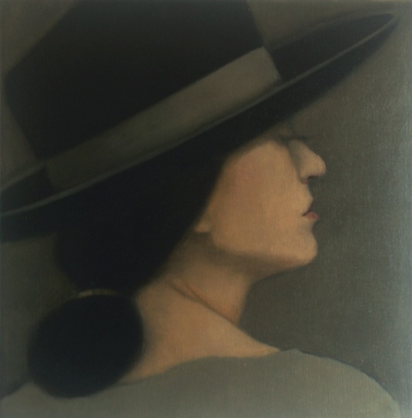
The work which transpired from earlier periods there explored the merging of contradictions. Religious elements crept into my imagery: sexually provocative angels, pregnant madonnas, the pairings of guilt and innocence in ambiguous narratives, etc. Although concepts have changed over the years, if there is a common thread throughout all the Spanish works it is one as entangled in my personal experiences while there than in the place itself.
Shoe Shine 1996
Spanish Hat 2011

